

Computer Vision

Date 16-Feb-2022

Section-1

Submitted to faculty: Professor Mehul Raval

Date of Submission: 16-02-2022

Student Details

Computer Vision-Super Image Resolution

| Roll No. | Name of the Student | Name of the Program |
| --- | --- | --- |
| AU1940109 | Jap Purohit | CV |
| AU1940034 | Varun Deliwala | CV |
| AU1940267 | Sahil Miskeen | CV |
| AU1940142 | Shail Patel | CV |

**Task Performed In This Week:**

Firstly, we went through the reference paper which is mentioned in the reference. Then we tried to replicate and create the model as per the reference paper. We were able to remove noise in an image to some extent but we weren’t able to remove the noise to the extent we expected. For this, we developed our own model and ran through various python code scripts.

**Outcomes:**

Original Image which is converted into Gray-Scale Image:

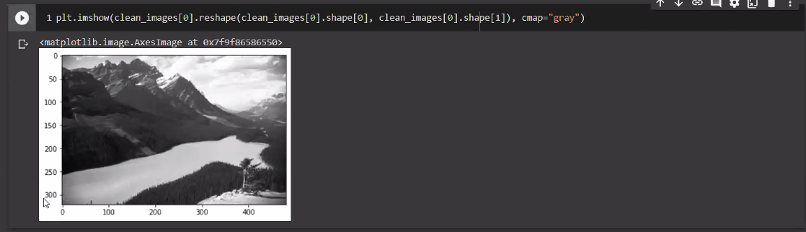

Noisy image:

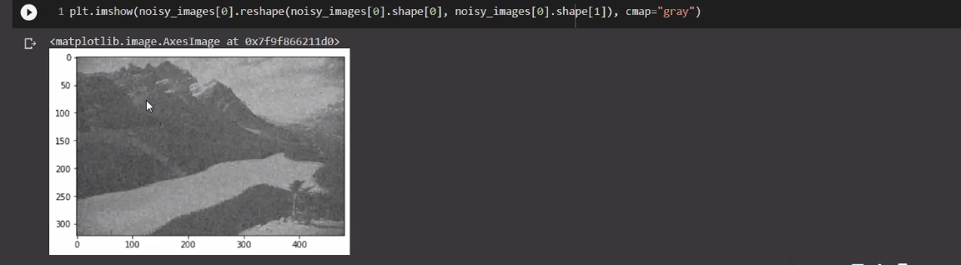

Image we obtained from the trained model:

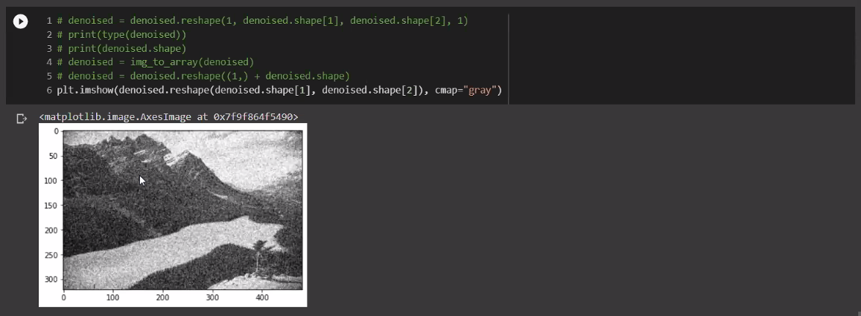

As we can see that image is denoised to great extent but we didn’t obtain the denoised image we expected to obtain.

**Task to be performed In Next Week:**

For this week, we will be working on this and try to denoise the image more and so it becomes similar to the original image. And try to find out more papers and go through them which can help in denoising the image.

**References:**

1. Beyond a Gaussian Denoiser: Residual Learning of Deep CNN for Image Denoising Kai Zhang, Wangmeng Zuo, Yunjin Chen, Deyu Meng, and Lei Zhang